Tel-Aviv University
The Iby and Aladar Fleishman Faculty Of Engineering
School of Electrical Engineering

Project Proposal
Wireless Video Stream Simulation



Instructors:
Mr. Moti Medina

Authors:
Mickey Friedmann, I.D. 060934593
Ayala Shachar, I.D. 039200779

Table of Contents
Table of Contents 2
Block Diagram 3
Wireless Project 3
Media stream Project 3
Introduction 4
Project Overview 4
Project Description 4
Project Goals 4
Approach 5
Design 7
Headers 7
Enumes 7
Structures 7
Classes 8
Timetable 8
Milestones 8
Hours Estimation – Video Stream Project 8
Hours Estimation – Wireless Project 8
References 8
Appendix A: Project Terminology 8

Block Diagram

Wireless Project
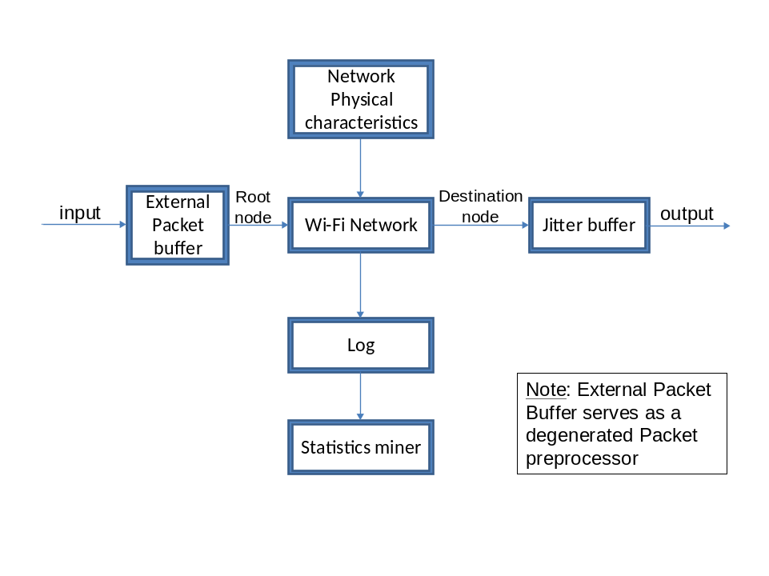

Media stream Project

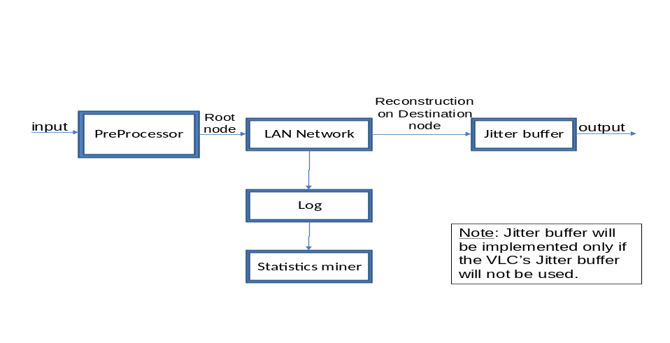

Introduction

Project Overview
Academic and commercial groups are nowadays developing systems which transfer video streams over mobile ad hoc networks (MANET). The MANET systems use algorithms which determine the transfer path of the data between the network's nodes.
Currently, there are no viable calculatory ways to test such systems in complex action scenarios.
The project purpose is to implement a test simulator. The simulator will test a table which contains the output of the algorithms for the transferring path and time slot management.

Project Description
The project will be divided into two sub modules:
- Wireless transferring of fix-sized packets as a stream (regardless of the video streaming packets' structure and content). The wireless communication will be based on IEEE 802.11 standard. The power of the received signal will be determined by the SINR (Signal to Noise & Interference ratio) calculation according to β parameter.
Extra requirement (given sufficient time): The power of received signal will be determined by a probabilistic function of the SINR.
- Video streaming over a network (regardless for the wireless connectivity). The video and audio compression will be mpeg 4 encoding using VLC open-source media technologies and media player.

Project Goals
- Using a unique algorithm, the Simulator shall strive to provide a high standard, modular and scenario based testing environment for MANETs. Thus providing the Communications industry specific tolerance and specifications for future Algorithm based networks.
- The simulation shall manage different action scenarios, thus enabling the research team to locate algorithm strengths and weaknesses. Scenarios will vary in SINR, spacial coordinates, temporal (time variant) design, Video stream quality, node data reception criteria – probabilistic SINR based decision rather than a deterministic yes/no criteria, BW, error rate, node Hyperedges (Hyperedges may be stationary or time variant during scenario). Communication shall be Unicast based (communication between two nodes).
- Defining criteria for future MANETs. Ranging from Video quality criteria to specific Algorithm time table management.

Approach
The project's development is divided into a basic implementation and an advanced one.
 | Basic Simulator | Advanced Simulator
Wireless | - Unicast  - Fixed number of nodes (approx. 5)  - Basic (fixed or linear) interference functions  - Simplified criteria for packet receive probability  - Simplified temporal network management.  - Wi-Fi Network characterization.  - Planar coordinates  - Simple queue management (immediate Queue functions, no margin cases)  - Jitter buffer for destination  - Basic statistics mining (OMNET++ Logger event based)  - Fixed Root node implementation (including packet transfer to root)  - Basic (static) scenario generation (scenario shall be manually implemented)  - "Sanity checks" for various scenarios, possible errors, margin cases. | - Message transfer probability defined by: BW, time slot, frequency, modulation, SINR (Signal to Noise & Interference, using Beta parameter), coordinates, Queue length prediction, a.p.p.s, Tlength, Packet length.  - Temporal management according to Algorithm Table.  - Complex (non linear) interference functions  - Spacial coordinates  - Advanced queue management (Margin cases must be dealt with. E.g., full Q, different Q characteristics (jitter buffer vs. simple node queue), etc.  - Complete statistics mining (specific events defined. E.g., traffic management, message management, delays, Queues status, etc.)  - Variant Root node implementation (scenario dependant)  - Complex (dynamic) and easier to use scenario execution (automated scenario generation)  - Error management (Response to message mishandling/network faults)
Streaming Media | - Unicast  - Single stream for scenario  - Two nodes path (just the source & destination ones)  - Static scenario  - No receive probability (it is constantly 100%)  - No statistics  - Basic Logger implementation (All events are chosen)  - Direct connection to VLC (output is automatically used by VLC) | - Multiple streams for scenario  - Multiple nodes path  - Dynamic scenario (Declaring the nodes in run time).  - Different receive probability for each scenario.  - Statistics collecting & Analysis:  - Queue size: expected vs. actual size.  - Jitter buffer delay  - "Black Screen" time as a function of jitter buffer length.  - TBD  - Advanced Logger implementation (The relevant events can be chosen).  - Handling possible dequeue rate vs. needed one of the nodes which aren't source/destination.
Combined | - Midterm presentation | - Final Presentation + Poster + Project book

In addition, there are some extras, if time permits:
 | Extras
Wireless | - Variant stream types  - T.b (traffic bandwidth) management according to SINR  - Flow control module  - Allow root to participate in multiple time slots
Streaming Media | - Dynamic change of nodes' coordinates
Combined | - Multicast implementation  - Scenario reconstruction according to Log  - Combination of two projects into one simulator.

Design

Headers
File Name | Description
Iostream.h | Declares objects that control reading from and writing to the standard streams.
fstream.h | Declares objects that control reading from and writing to files.

Enumes
Enume Name | Options
eventType | eDbg, eInitEvent, eOperationEvent, eFunctionalityTests, eEventNo
fileStatusType | eInit, eOpened, eClosed, eNA

Structures

Address
Field Declaration | Description
int x | x Cartesian coordinate
int y | y Cartesian coordinate
Int z | Z Cartesian coordinate
int ID | The node serial number

BW
Field Declaration | Description
float rxf | Receive frequency (Predefined channel)
float txf | Transmit frequency (Predefined channel)
Float databw | Data transfer bandwidth [kb/sec]

TableLine
Field Declaration | Description
int slot | The slot number
int freq | The frequency used
int transNode | The root node
int streamNo | The packet number
int recNo | The number of receivers.
Node* recList[destNo] | Array of the pointers for the receivers nodes.
int transRate | The receive rate
int rxPower | The power at which a signal is received at the destination node
TBD Modul. | TBD
int avrPacketNo | Average #packets to be transmitted at the slot on the edge

Classes

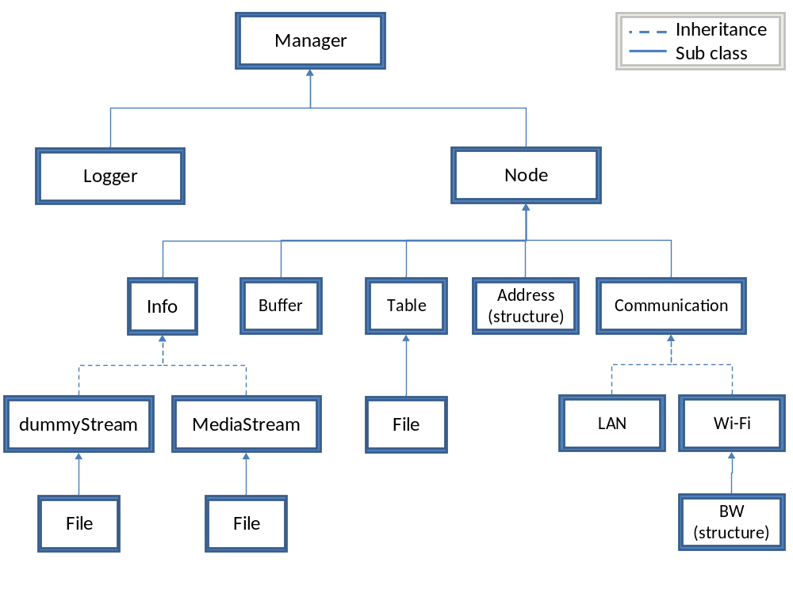

Class Name | Description
Manager | Overall scenario management class
Node | Node specification and control
Logger | Event logging and result manipulation
Communication | Overall communication management (whether Wi-Fi or LAN)
LAN | Sub class of Communication for Streaming media project
WiFi | Sub class of Communication for Wireless project
Table | Algorithm table. Received as input.
Info | Sending data management (whether MediaStream or dummyStream)
MediaStream | Video stream management
DummyStream | Dummy stream management for WiFi project.
Buffer | Queues used for nodes and input/output. Define Preprocessor buffer, Jitter buffer and external packet buffer.
File | Files input/output management

Manager

Properties and Members:
Declaration | Description
Node nodes[nodesNo] | The network's nodes array
Logger log | The log handling object
int nodesNo | The number of nodes within a network

Methods:
Declaration | Description
Initialize() | Overall constructor
Finish() | Overall destructor
addNode() | Creates new node (for network changes during scenario)
deleteNode(int ID) | Deletes specified node
createNetwork(Table) | Dynamically create network according to input table
updateNetwork(Table) | Dynamicaly update network according to input table

Buffer

Properties and Members:
Declaration | Description
QueueType queue[queueSize +extraSize] | Array of QueueType - The queue content
int queueSize | Max number of objects inside the queue
int currSize | Current number of objects inside the queue
int extraSize | Extra number of objects that can be inserted into the queue

Methods:
Buffer(int maxQueueSize) | The class constructor.
Bool insert(QueueType packet) | Inserts packet into queue Q. Return if succeed.
QueueType remove() | Extracts first packet in queue Q.
int depth() | Returns depth of queue Q (number of members).
Check_Q() | Checks the status of Queue. Used for Queue management. TBD

Node

Properties and Members:
Declaration | Description
Communication comm | Node's communication's management object
Address addr | Node's address object
Info data | Packet Data
Buffer queue | Stored packet queue

Methods:
Declaration | Description
Node() | Creates new node (for network changes during scenario)
~Node() | Deletes specified node
Send(Node1,Node2, packet) | Send message with packet from Node1 to Node2

Logger

Properties and Members:
Declaration | Description
Bool eventEnable[eEventNo] | Array that indicates if the log writing of a specific event is enabled/disabled (allows simplifying log reports to necessary events only)

Methods:
Declaration | Description
void write2log(eventType currEvent, char* descMsg) | Writing a log event, according to its type and description msg.
void writeGraphicLog(TBD) | Writing a log line on simulation's GUI
Void manipulate(TBD) | Extract necessary data from Log file and present it (preferably via GUI). This routine implements data mining according to project statistics needs (e.g., max Queue depths, average/max path length, number of errors per simulation etc.)
Bool eventEnabled(eventType event) | Returns if the writing to log of specific event is enabled.
Void setEventStatus(eventType event, bool status) | Setting the status of a specific event. Status is true for enabled and false for disabled.
Void setAllEventsStatus(bool* eventsArrayPtr) | Setting the status of all the events, according to the eventsArrayPtr - array of bool type with eEventsNo cells.

Info

Methods:
Declaration | Description
virtual void preparePacket(TBD) | Gathering the packect's content before sending
virtual void handlePacket(TBD) | Handling the received packet's content
virtual int packetSize(packetType packet) | Return the physical size of a packet

MediaStream

Properties and Members:
Declaration | Description
File inputFile | Handling file's IO for the received stream
File outputFile | Handling file's IO for the sent stream
int iFrameLength | The length of the I-Frames of the stream
int pFrameLength | The length of the P-Frames of the stream
int iFrameRation | The ratio: #iframe/(#iframes + #pframes)
int videoFrameRate | The camera's frame rate
int maxStreamDelay | The "dead-line" of each frame for entering to the jitter buffer.

Methods:
Declaration | Description
void preparePacket(TBD) | Gathering the packect's content before sending
void handlePacket(TBD) | Handling the received packet's content
virtual int packetSize(packetType packet) | Return the physical size of a packet

DummyStream

Properties and Members:
Declaration | Description
File inputFile | Handling file's IO for the received stream
File outputFile | Handling file's IO for the sent stream

Methods:
Declaration | Description
void preparePacket(TBD) | Gathering the packect's content before sending
void handlePacket(TBD) | Handling the received packet's content
virtual int packetSize(packetType packet) | Return the physical size of a packet

Communication

Properties and Members:
Declaration | Description
int commType | WiFi or LAN

Methods:
Declaration | Description
virtual void sendPacket()
virtual void receivePacket()
virtual int receiveProbability(Node1,Node2, packet) | Returns the probability of info transfer (in percents) between node1 & node2. E.g., for Wireless project, probability is derived from SINR, previous simulation results and physical characteristics while as for Video Stream project, probability is predefined within scenario.
virtual void idle() | Decides whether or not to send packet and handles it

LAN

Properties and Members:
Declaration | Description
int receiveProbability | The LAN receive probability (in percents)

Methods:
Declaration | Description
virtual void sendPacket()
virtual void receivePacket()
virtual int receiveProbability(Node1,Node2, packet) | Returns the probability of receive (in percents) between node1 & node2.

WiFi

Properties and Members:
Declaration | Description
Float signalIn | Incoming signal power
Float signalOut | Outgoing signal power
Float noise
Float interference
Bool chance | Stores the result of probability() function.
Float slot | Timeslot.
Float beta | Beta parameter
BW bandwidth | Substructure containing node frequency
Float apps | a.p.p.s parameter
Float tlength | Tlength parameter
Float Plength | Packet length

Methods:
Declaration | Description
int receiveProbability(Node1,Node2, packet) | Returns the probability of receive (in percents) between node1 & node2.
Float SINR(float S,N,I) | Receives Signal (S), Noise (N) and Interference (I) and calculates SINR
Void ManUpdate(WiFi) | Manually update the WiFi physical characteristics
Float i-f(Node) | Calculates and returns node interference according to mathematical interference function. Calculated interference is then used for SINR calculation.

Table

Properties and Members:
Declaration | Description
tableLine Table[tableLinesNo] | Array containing all given input in a predetermined table structure.
int tableLineNo | The number of lines in the table.

Methods:
Declaration | Description
ConvertTable(char* filename) | Convert input file into table

File

Properties and Members:
Declaration | Description
fstream fileHndl
char filename[…] | Handled file name
fileStatusType fileStatus | File Status (opened/closed)

Methods:
Declaration | Description
bool open(TBD) | Opening the file and return if succeed
void close() | Closing the file
int fileStatus() | Returning the file's status
void write(byte* buf, int bufLen) | Writing to file from "buf"
int read(byte* buf, int bufLen) | dicing file into packets of "bufLen" size and inserting packets into queue "buf"

Timetable

Milestones
 | Milestone | Date
1 | Basic simulator implementation | 03/12/2009
2 | Running Basic scenarios and performance analysis | 21/01/2010
3 | Midterm presentation | 18/03/2010
4 | Final simulator implementation | 01/05/2010
5 | Running Complex scenarios and performance analysis | 10/06/2010
6 | Final presentation | 22/07/2010
7 | Project's completed | 01/09/2010

Hours Estimation – Video Stream Project
 | Assignment description | Verification | Date
 | Establishing workstation | Environments installed and running | 24/09/2009
 | Learning Omnet++, Mixim, C++ | Building a simple simulation | 01/10/2009
 | Writing project proposal | Paper submitted | 15/10/2009
 | Getting Familiar with MPEG, video stream, VLC  (For example: mpeg packets type, mpeg file structure, how to use the jitter buffer, vlc control from OMNET++). | Writing 'Review of Literature' chapter of the project book, updating 'References' chapter accordingly | 2/11/2009
 | Writing detailed design documentation | Complete documentation in cooperation with WiFi project. | 5/11/2009
 | Basic service classes (Logger, Buffer, File, Table) implementation + Writing functionality tests | Performing the functionality tests, debug messages, log. Implementation of all the classes design (members, functions, inheritance, etc). | 12/11/2009
 | Info & Communication classes implementation + Writing functionality tests | Performing the functionality tests, debug messages, log. Implementation of all the classes design (members, functions, inheritance, etc). | 12/11/2009
 | LAN class implementation + Writing functionality tests | Performing the functionality tests, debug messages, log. Implementation of all the class design (members, functions, inheritance, etc). | 12/11/2009
 | Basic MediaStream class implementation + Writing functionality tests | Performing the functionality tests, debug messages, log. Implementation of all the class design (members, functions, inheritance, etc). | 19/11/2009
 | Basic Manager & Node classes implementation + Writing functionality tests | Performing the functionality tests, debug messages, log. Implementation of all the classes design (members, functions, inheritance, etc). | 26/11/2009
 | Basic simulator integration | Closed simulator Version 1.0.  Run fixed simulations. | 03/12/2009
 | Running basic scenarios & performance analysis | Successful run of all given scenarios. | 21/01/2010
 | Software improvements after analysis | Updated relevant documentation | 25/02/2010
 | Midterm presentation preparation | Closed Simulator version 2.0. Necessary documentation, presentation | 18/03/2010
 | Adding statistics design to documentation & updating design for the advanced simulation | Complete documentation in cooperation with WiFi project. | 25/03/2010
 | Updating service classes (Logger, Buffer, File, Table) | Updating functionality tests and performing the tests, debug messages, log. | 01/04/2010
 | Updating Info, Communication & LAN classes | Updating functionality tests and performing the tests, debug messages, log | 01/04/2010
 | Dynamic network implementation | Updating functionality tests and performing the tests, debug messages, log | 08/04/2010
 | Updating MediaStream class implementation | Updating functionality tests and performing the tests, debug messages, log | 15/04/2010
 | Updating Manager & Node classes implementation | Updating functionality tests and performing the tests, debug messages, log | 22/04/2010
 | Advanced simulator integration | Closed simulator Version 3.0.  Run fixed simulations. | 01/05/2010
 | Running complex scenarios & performance analysis | Successful run of all given scenarios. | 10/06/2010
 | Software improvements after analysis | Updated relevant documentation | 01/07/2010
 | Final presentation preparation | Closed Simulator version 4.0. Necessary documentation, presentation | 22/07/2010
 | Project completed | Final simulator version 5.0.  Complete project book | 01/09/2010

Hours Estimation – Wireless Project
 | Assignment description | Verification | Date
 | Establishing workstation | Environments installed and running | 24/09/09
 | Learning Omnet++, Mixim, C++ | Building a simple simulation | 01/10/09
 | Writing project proposal | Paper submitted (2nd draft) | 15/10/09
 | Getting Familiar with WiFi, physical characteristics | Write Paper stating values and tolerance of all physical parameters. | 22/10/09
 | Build Project book outline. | Project book is devided into Chapters ready to be filled. All existing data is within book. Write Review of literature. | 29/10/09
 | Building WiFi Network mainframe (Fixed Node number) | Simple (Fixed node number, fixed Root and target node) implementation running (messages sent but without all physical parameters). | 29/10/09
 | Writing specific function documentation | Complete documentation in cooperation with Stream project. | 12/11/09
 | Basic packet receive criteria implementation (Basic BW management, etc.) | Basic physical parameters introduced into WiFi class. Simulation must run. | 19/11/09
 | Queue implementation | Simple queue implementation (class, members, basic functions). | 26/11/09
 | Basic simulator implementation | Closed simulator Version 1.0.  Run fixed simulations. | 03/12/09
 | Basic Logger implementation | Creating Logger Class and basic events (e.g. message types, errors, nodes involved, time of occurrence, etc.) | 17/12/09
 | Table implementation | Build Table class, members and functions. Basic scenario generator according to table. | 24/12/09
 | Basic temporal management | Allow Basic scenario changes during runtime (spacial, physical parameter wise or Node number changes). | 31/12/09
 | Basic Scenarios | Allow input of at least 3 basic scenarios and simulation run. | 07/01/10
 | Performance analysis ("Sanity checks") | Perform sanity checks. Update physical parameters. Debugging.  Writing down conclusions of current simulation version. Catching up with unfinished (heaven forbid) project goals. | 21/01/10
 | Software improvements after analysis | Set Video/Packet criteria for continued work. Prepare simulation for presentation (GUI, final testing etc.).  Simulation must comply with "Basic Simulation" column within "Approach" table. | 04/03/10
 | Preparations for Midterm presentation | Closed simulator version 2.0.  Create necessary documentation (docs, presentation etc.). | 18/03/10
 | Advanced packet receive criteria implementation (including full BW management, SINR, etc.) | All physical and communication parameters (Packet size, traffic bandwidth (t.b- kb/sec), etc.) must be implemented and fully functional. In addition, a.p.p.s parameter will affect Send decision and possibly affect route. | 01/04/10
 | Advanced temporal management (both spacial and physical characteristics wise) according to Table. | Allow all necessary timely changes to be implemented during scenario run. | 08/04/10
 | Advanced Queue management | Complete queue management (what to do when q is full, queue statistics, etc.) | 15/04/10
 | Variant Root node implementation | Allow root node to change according to scenario (change is implemented before and not during simulation) | 15/04/10
 | Scenario generator improvement (dynamic Networks) | Adjust scenarios to include all current parameters and be user friendly as possible. | 22/04/10
 | Error management | Sanity checks, debugging, define failures due to interference or low reception power for future statistics mining. TBD | 29/04/10
 | Simple statistics miner implementation | Allow data analysis. User interface is irrelevant. Statistics shall include nodes Queue status at time of errors, node physical characteristics, etc. | 01/05/10
 | Final simulation implementation | Closed Simulator version 3.0.  Simulation must comply with "Advanced Simulator" column within "Approach" table. | 01/05/10
 | Running complex scenarios | Running all given scenarios and performing data analysis. | 20/05/10
 | Performance analysis & software improvements | Documenting conclusions from various scenarios and physical tolerance of Wi-Fi network. Catching up with unfinished (heaven forbid) project goals. | 10/06/10
 | Full Statistics miner implementation | Finalize miner and build easy to handle User interface. Statistics necessities:  - Obtained BW.  - Queue lengths.  - Packet error rates per node (error types specified).  - Overall packet delay (start to end).  - Jitter buffer delay.  - Throughput aspects. | 24/06/10
 | Preparing for Final presentation | Docs, presentation, posters, classroom preparations.  Closed simulation version 4.0. | 22/07/10
 | Documentation and project completion. | Final adjustments to simulator:  Final simulator version 5.0.  Finalize documentation (project book, user manual for future researchers, instructions for input writing (how to prepare input tables for the simulations). Etc.). | 01/09/10

References
The bibliography was written according to MLA 7 standards with EasyBib wizard (http://www.easybib.com/).

Even, Guy & Medina, Moti. Simulation specification report RESCUE milestone. Tel Aviv University: School of engineering, 2009. Print.
Austerberry, David. The Technology of Video & Audio Streaming. Oxford: FocalPress, 2003. Print.
IEEE 802.11. Wikipedia. Web. 5 Oct. 2009. <http://en.wikipedia.org/wiki/IEEE_802.11>.
Mixim Wiki. SourceForge. Web. 5 Oct. 2009. <http://sourceforge.net/apps/trac/mixim/>.
Mobile Ad Hoc Network. Wikipedia. Web. 5 Oct. 2009. <http://en.wikipedia.org/wiki/Mobile_ad_hoc_network>.
Moving Picture Experts Group. Wikipedia. Web. 5 Oct. 2009. <http://en.wikipedia.org/wiki/Mpeg>.
OMNeT++ User Community Wiki. PmWiki. Web. 5 Oct. 2009. <http://www.omnetpp.org/pmwiki/>.
Packet forwarding. Wikipedia. Web. 5 Oct. 2009. <http://en.wikipedia.org/wiki/Packet_forwarding>.
Streaming Media. Wikipedia. Web. 5 Oct. 2009. <http://en.wikipedia.org/wiki/Streaming_media>.
Video Compression. Wikipedia. Web. 5 Oct. 2009. <http://en.wikipedia.org/wiki/Video_compression>.
Wi-Fi. Wikipedia. Web. 5 Oct. 2009. <http://en.wikipedia.org/wiki/Wifi>.

Appendix A: Project Terminology

Mobile Ad Hoc Networks (MANET):
A mobile ad hoc network (MANET) is a self configuring network of mobile devices connected by wireless links rather than Transducers. Each device (called node) may act as an independent router and be free to move independently in any direction. Therefore, it allows reconfiguration around broken or blocked paths.
The node mobility causes a frequently change of transfer path.

Video Stream:
Live video presented to the end-user, while being delivered by a streaming provider.

IEEE 802.11 :
IEEE organization's set of standards for wireless local area network (WLAN) computer communication. Most popular standards are: 802.11a, 802.11b, 802.11g, 802.11n.

WiFi:
Wi-Fi is a trademark owned by the Wi-Fi Alliance (WFA) trade group. Wi-Fi networks use the IEEE 802.11 standard for providing secure, reliable and fast wirless connectivity.

MPEG:
The Moving Picture Experts Group (MPEG) is ISO's standards for audio and video compression and transmission. (Video compression is used for reducing the quantity of data used to represent digital video images.)

Omnet++:
Omnet is a discrete event simulation environment. Its primary application area is the simulation of communication networks.
Although OMNeT++ is not a network simulator itself, it is currently gaining widespread popularity as a network simulation platform in the scientific community as well as in industrial settings, and building up a large user community.
One of its strengths is being a currently developed open source environment, allowing the team to take part in the future development of the environment.

Mixim:
MiXiM (mixed simulator) is a simulation framework for wireless and mobile networks using the OMNeT++ simulation engine. Mixim Framework shall be used for IEEE 802.11 and complex routing implementations.

